# C:\Users\Osten\Grupp29Asciicam\res\drawable-hdpi\asciicamlogo.pngAsciiCam User Guide

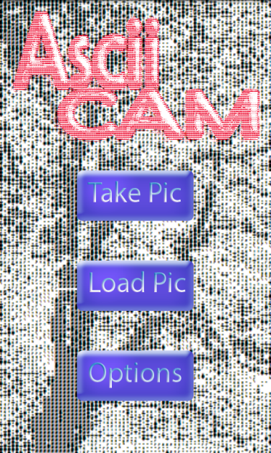

AsciiCam is an application for Android (2.2 or newer) developed and published under the GNU General Public License. AsciiCam allows you to manipulate pictures taken or already existing on your memory card using various filters and options.

When the application is started you will be greeted by a menu screen and the following buttons: (See figure 1 to the right).

* **Take Pic**. From this screen you can either take a picture by pressing the camera button or return to the menu screen by pressing the button labeled "Menu". (See figure 2).

If you choose to take a picture you will have the options of returning to the previous screen (Back), converting the taken picture with the filter chosen (Convert) or saving the picture taken (Save). (See figure 3).

*Figure 1 - Menu*

By choosing Convert, the result will be showed on your screen and new buttons   
will be available. *Menu* will return you to the menu screen, *Options* allows you to change filter and other options and by pressing *Save* the application downloads the picture to your memory card while remaining on the same screen. (See figure 4).

* **Load Pic**. Pressing this button will open up your phones gallery. Browse for a picture of your choosing and you will be given the same options as if you've just taken the picture, but with the picture of your choosing. (See figure 3).
* 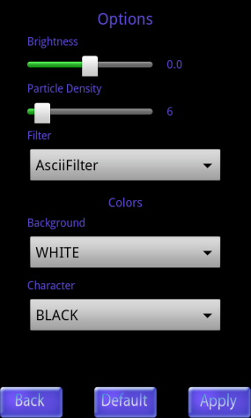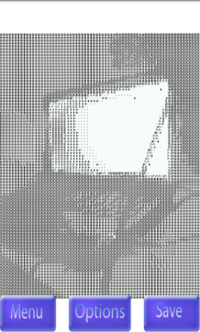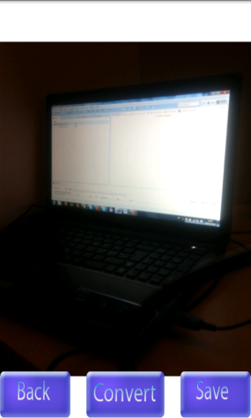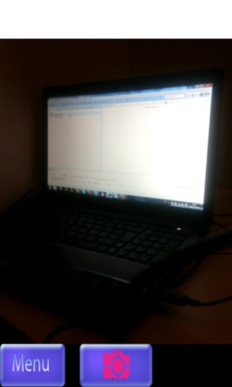**Options**. By pressing this button the applications Options will open. In here you have some features for the filter and the pictures. You can change the brightness and particle density of the pictures. You have two different filters that you can choose between, these are *Ascii* and *Grayscale.* When you select the Ascii (this will be the default) you will also have two other options to change the colors of the background and the signs for the conversion. When you press *Back* from this screen you will return to the previous screen without applying any changes to the settings. By pressing the *Default* button the changes will be reset to default. If you want to apply your changes press the *Apply* button, this will apply your settings to the conversion and return you to the previous screen. If you got to Options from the converted picture this will also reconvert the picture with your new settings. (See figure 5).

*Figure 5 - Options*

*Figure 4 - Converted*

*Figure 3 - Preview*

*Figure 2 - Camera*